**ChatGPT Friend or Foe**

Aayush Dahal

Abstracts

Key Words

**1.Introduction**

By developing and analyzing smart software and hardware, referred to as intelligent agents, that are capable of carrying out a variety of tasks, artificial intelligence (AI) has had an impact on how we go about our daily lives. According to Bansal and Khan (2018), a chatbot is a human-computer interaction (HCI) model and artificial intelligence application. A chatbot is defined as "A computer program designed to simulate conversation with human users, especially over the Internet" by the dictionary.

Apart from replicating human contact and delighting people, chatbots are effective in several other domains like education, business and ecommerce, health, and entertainment.

**1.1 History of chatbots**

In 1950, Alan Turing proposed the Turing Test, which helped make chatbots more well-known. Eliza was the first chatbot, and it used pattern matching and a response system based on templates. ALICE received the Loebner Prize in 1995, and PARRY was created in 1972. Virtual personal assistants like Apple Siri, Microsoft Cortana, Amazon Alexa, Google Assistant, and IBM Watson, as well as chatbots like SmarterChild, were developed.

As shown in Fig.1 according to Scopus, interest in chatbots increased quickly, especially after 2016. While a large number of less well-known chatbots are relevant to research and their applications, many chatbots were created for industrial solutions.

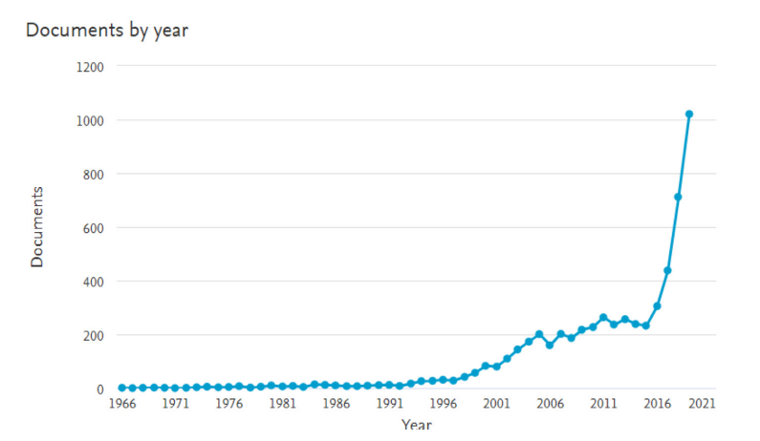

Fig 1. Search Results in Scopus (Scopus preview—Scopus—Welcome to Scopus, 2020), from 1966 to 2019 for the keywords ‘‘chatbot’’ or ‘‘conversation agent’’ or ‘‘conversational interface’’

**1.2 Significance of chatbots**

Chatbots are computer programs designed to simulate conversation with human users through text or voice interactions. They have the potential to streamline customer support, improve customer experience, and provide businesses with valuable insights into customer behavior. They can handle multiple customer queries at once, provide 24/7 availability, reduce staffing costs, personalize responses, enhance customer experience, and collect and analyze data on customer interactions. These benefits make chatbots an increasingly important tool for businesses looking to improve their customer service and stay competitive in today's digital landscape.

**1.3 Categories of chatbots**

Chatbots have become increasingly dynamic with the arrival of new technologies, so a precise classification has become subjective to the scope of their use. Chatbots can be classified into various categories based on criteria such as mode of interaction, knowledge domain, usage and design techniques. The broad classification can be done based on the following criteria: mode of interaction, knowledge domain, usage and design techniques.

1. Interaction Mode (Text based, or voice/speech based)

2. Chatbot Application (Task-Oriented or Non-Task-Oriented)

3. Rule-based or AI (Machine learning, Deep learning etc.)

4. Domain-Specific or Open-Domain

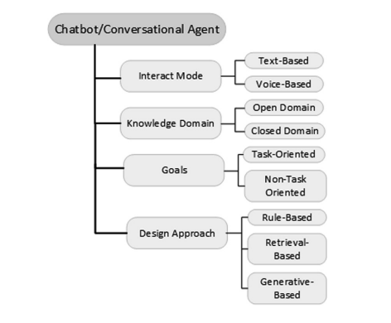

Fig 2. Broad classification of chatbots

But in general, Chatbots are divided into two categories based on their goals.

1.Task-oriented chatbots

2.Non-task-oriented chatbots

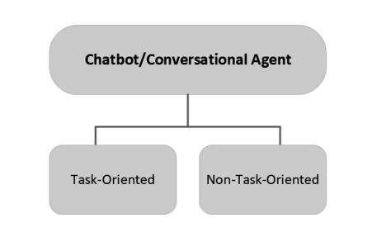

Fig 3. Main classification of chatbots

Non-task-oriented chatbots can mimic a conversation with a human in open domains, whereas task-oriented chatbots are made to conduct brief discussions in closed domains.

**1.4 ChatGPT history and difference with normal chatbot**

The GPT (Generative Pre trained Transformer) was first introduced by OpenAI in 2018 as a language model that uses deep learning techniques to generate human-like text. It was trained on a large corpus of text data, allowing it to generate coherent and contextually relevant responses to various prompts. GPT-1, the first version of the model, was followed in 2019 by GPT-2, which was even larger and more powerful. GPT-3, the latest version, was released in 2020 and has set new standards in the field of AI language generation. ChatGPT has several strengths that make it useful in scientific project writing, such as its ability to generate contextually relevant responses, being trained on a vast corpus of text data, and being able to generate large amounts of text quickly.